**CRUD Operations**

*Note: Use Dot Net core 6.0*

Install below packages:

1. Microsoft.EntityFrameworkCore
2. Microsoft.EntityFrameworkCore.Tools

Step 1: Create a “Employee” class under “Models” folder.

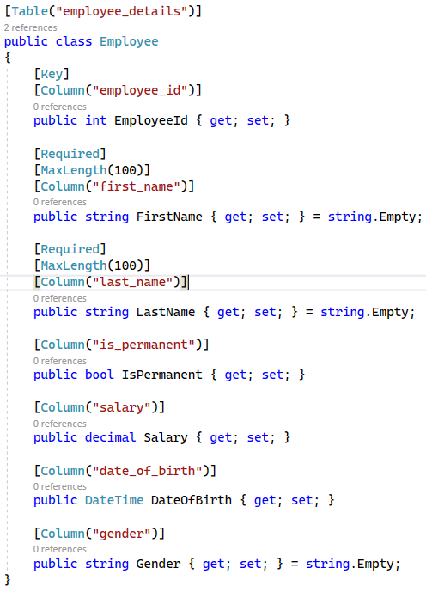

Step 2: Create “AppDbContext” class under “Models” folder and add below code.

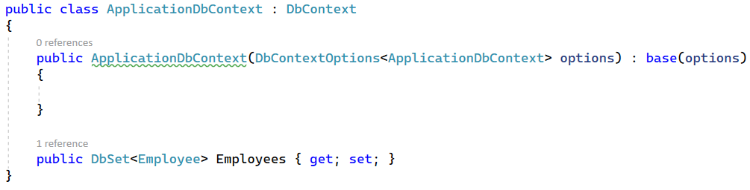

Step 3: In “appsettings.json” file add below code for connection string.



Step 4: In “program.cs” file add below code.

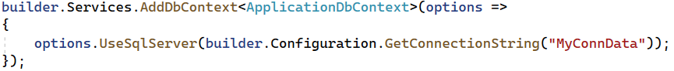

Step 5: In package manager console run below command to create DB in server with corresponding tables.

1. Add-migration CreateNewDB
2. Update-database

Step 6: Add few data in tables in SQL server.

Step 7: In API controller add below code to get data from DB. (Write other methods like insert, update, and delete).

